Direction

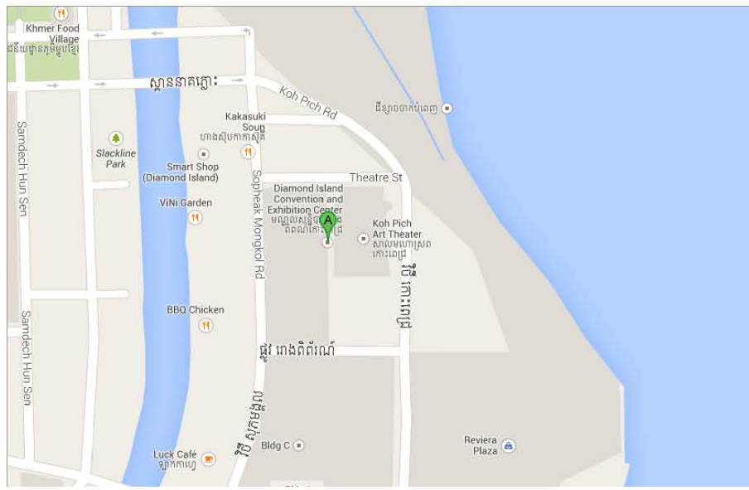
REDD+ Concert
Floor Plan

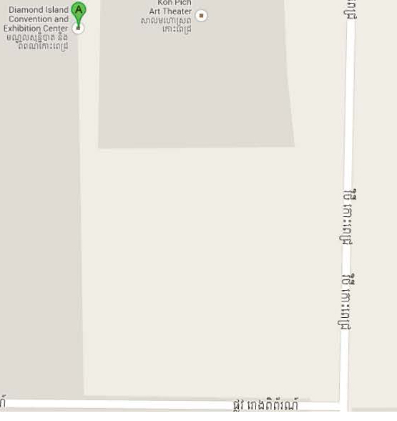
Smart Booth

REDD+ Booth
(12m x3m)
Audiences Standing
VIP and chairs set up
REDD+ Concert Stage

Smart Booth

