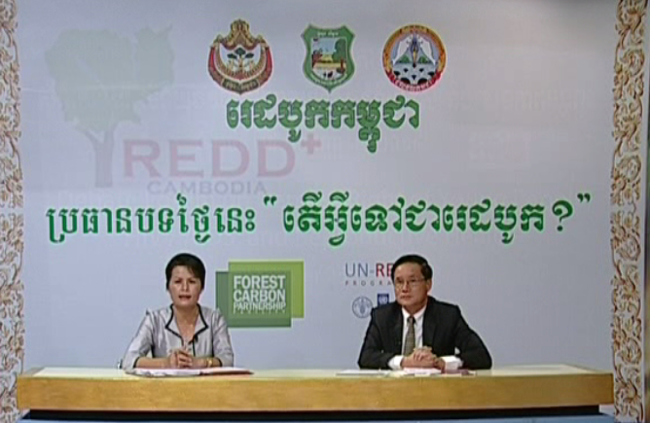
REDD+ TV Talk show
Topic 1: What is REDD+
H.E Dr. Chea Sam Ang, Deputy Director General, Forestry Administration, and National Project Director, FCPF, was a speaker at the National Television of Cambodia talk show on “What is REDD+?”
The talk show contributes to enhancing public awareness and support for REDD+ in Cambodia.

